Velaisance Retail Website Guide
Lip gloss candles and room and linen sprays
Prepared for The Elixir Vanity • October 31, 2026
This guide brings together 11 products from your uploaded Product List and product images. It includes collection introductions, individual descriptions, images, internal SKUs, specifications, suggested website fields, and proposed customer care copy.

LUSTRE by Velaisance
An elevated finishing touch. Discover five expressive lip gloss shades, from understated nudes to rich wine tones. Find your signature shade or make room for all five.

The Elixir Ritual Candle Collection
Set the mood. Honor the moment. Discover four signature fragrances crafted with soy wax and presented in elegant black tins. From fresh botanicals to soft musk and coastal notes, each candle invites you to slow down and turn everyday moments into sacred self-care.

The Elixir Atmosphere Collection
Scent your space. Elevate your state. Discover Séréne Lavender and Clear Mind Eucalyptus, two room and linen sprays that bring spa-inspired luxury to your surroundings. A simple finishing touch for spaces that invite you to pause, unwind, and feel at home.

Details to complete before publishing
- Confirmed retail pricing: lip gloss $25 each; candles $19.99 each; room and linen sprays $20 each or any two for $35.
- Lip gloss net contents are 5 mL / 0.17 fl oz per supplied P245 specification. Confirm shade-specific ingredient lists from a legible supplier label. For sprays, obtain the complete formula or label ingredient disclosure, fabric compatibility, and supplier safety directions. Candle burn time, wick material, and tested maximum burn duration are not supplied.
- Care wording in this guide is proposed copy; check it against supplier instructions and the final product label. Do not publish claims such as nonsticky, vegan, hypoallergenic, nontoxic, or disinfecting without supporting product information.
- Séréne spelling is standardized to the supplied candle and spray image labels. Keep this spelling consistent across the website and final labels.

Product and SKU register
SKU format follows your existing system: EV for The Elixir Vanity, VEL for Velaisance, a unique item code, and 01 for the current variant. Each code below is assigned to one retail unit; future sizes or packs need distinct variant codes.
Product | SKU | Retail USD
Bellini Lip Gloss | EV-VEL-LGB-01 | $25.00
Cashmere Lip Gloss | EV-VEL-LGC-01 | $25.00
Bordeaux Lip Gloss | EV-VEL-LGD-01 | $25.00
Cognac Lip Gloss | EV-VEL-LGN-01 | $25.00
Rosé Lip Gloss | EV-VEL-LGR-01 | $25.00
Emerald Aire Candle | EV-VEL-CEA-01 | $19.99
Séréne Candle | EV-VEL-CSE-01 | $19.99
Velours Candle | EV-VEL-CVE-01 | $19.99
Sanctuaire Candle | EV-VEL-CSA-01 | $19.99
Séréne Room and Linen Spray | EV-VEL-SSL-01 | $20.00
Clear Mind Room and Linen Spray | EV-VEL-SCE-01 | $20.00

Store setup fields
Add your actual stock quantities, supplier barcodes if any, shipping weights, tax settings, and fulfillment and return policies. Internal SKUs are not UPC barcodes. Preserve the assigned SKU when changing price or copy. Track candle and spray bundles as separate products if you sell them as fixed packs.

Image sources
All product images are from your uploads and are embedded with each listing. Their product names, shade or scent labels, and visible sizes were used alongside Product List (1).docx. The images remain visually unchanged. Net contents and ingredients should follow actual product packaging and supplier records. Lip gloss dimensions and net contents were added from the supplier C22 carton and P245 tube specification images.

Bellini Lip Gloss
SKU EV-VEL-LGB-01
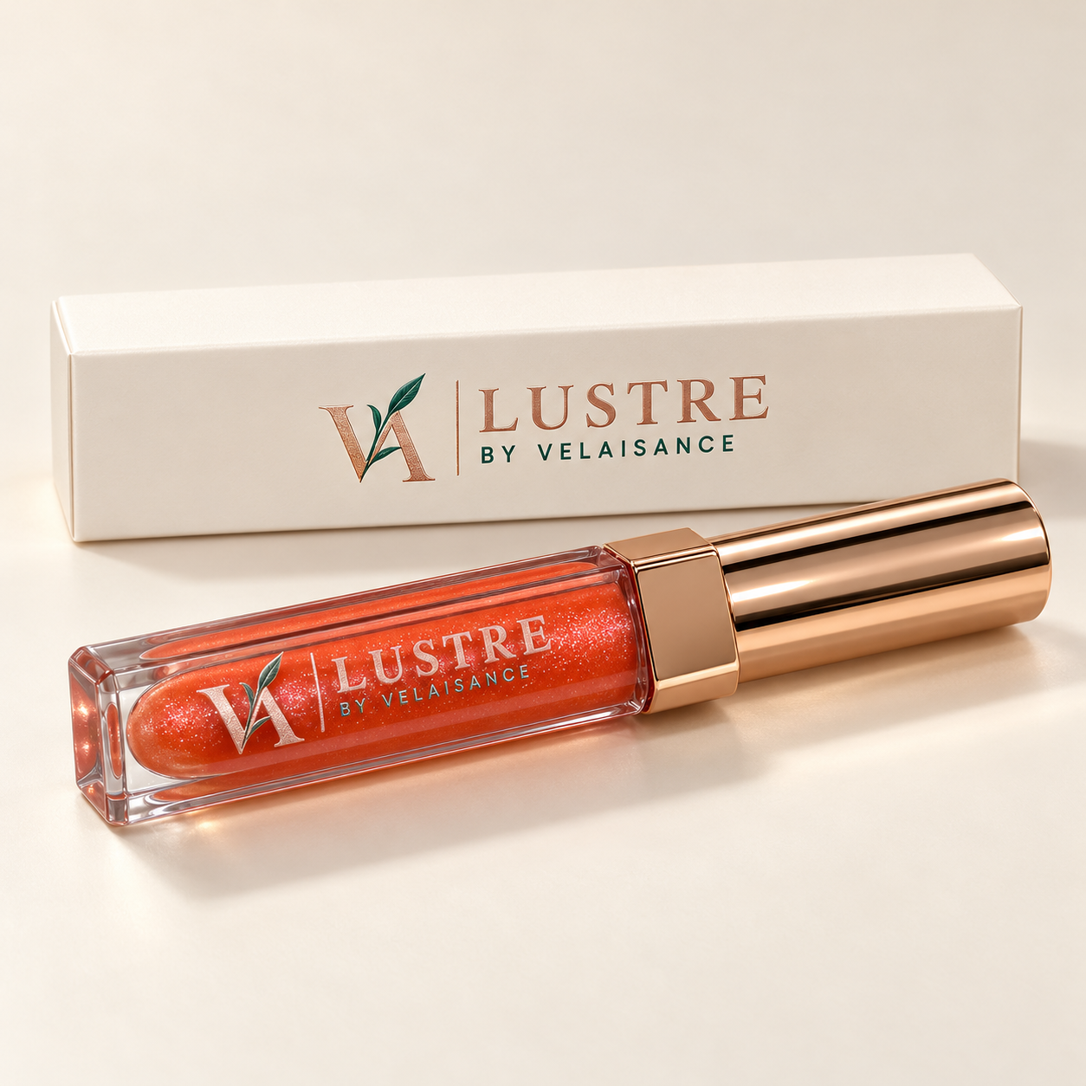
Website title Bellini | Peach Coral Lip Gloss
Brand and collection LUSTRE by Velaisance
Price $25.00 each
Shade and finish Peach Coral | Gloss finish
Size 5 mL / 0.17 fl oz. Box C22: 23 × 23 × 115.5 mm. Tube P245: 18 × 18 × 112 mm. Supplier-listed gross weight: 27.1 g; verify packed shipping weight separately.

Website description
A little sunshine for your lips. Bellini pairs soft peach with a playful touch of coral for a fresh, luminous look. The perfect finishing touch for brunch dates, golden-hour moments, and everyday Gleaux.
Suggested directions Apply with the included applicator to lips. Wear alone or over lip color and reapply as desired.
Suggested care For external use on lips only. Do not share applicators. Stop use if irritation occurs. Follow the supplier’s storage and period-after-opening guidance.
Ingredients Pending supplier’s full ingredient list; no ingredient or formulation claims assigned.
Suggested URL /elixir-vanity/bellini-lip-gloss
SEO title Bellini Lip Gloss | Velaisance
Meta description Shop Bellini lip gloss by Velaisance. Peach Coral for your lip wardrobe. Available at The Elixir Vanity.
Image alt text Bellini LUSTRE by Velaisance lip gloss with rose gold cap and ivory carton.

Cashmere Lip Gloss
SKU EV-VEL-LGC-01
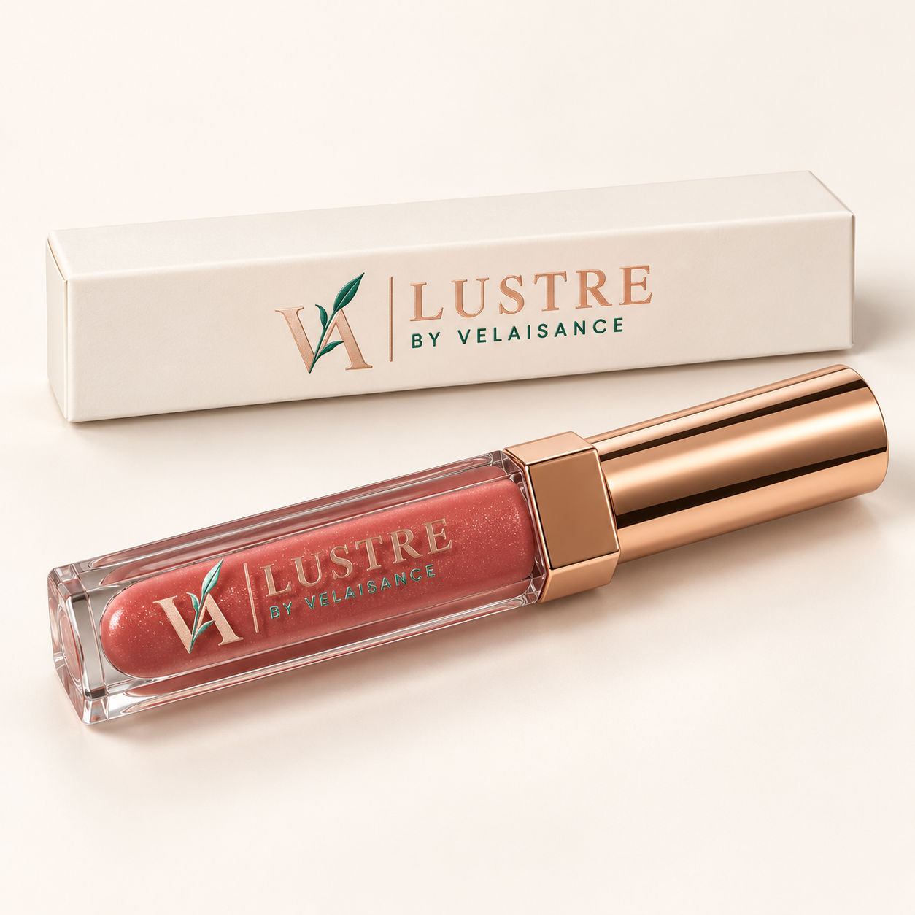
Website title Cashmere | Rosy Nude Lip Gloss
Brand and collection LUSTRE by Velaisance
Price $25.00 each
Shade and finish Rosy Nude | Gloss finish
Size 5 mL / 0.17 fl oz. Box C22: 23 × 23 × 115.5 mm. Tube P245: 18 × 18 × 112 mm. Supplier-listed gross weight: 27.1 g; verify packed shipping weight separately.

Website description
Quiet luxury, beautifully expressed. Cashmere is a sophisticated rosy nude that brings subtle warmth and polish to your look. Effortlessly elegant, whether worn with barely-there makeup or a defined lip.
Suggested directions Apply with the included applicator to lips. Wear alone or over lip color and reapply as desired.
Suggested care For external use on lips only. Do not share applicators. Stop use if irritation occurs. Follow the supplier’s storage and period-after-opening guidance.
Ingredients Pending supplier’s full ingredient list; no ingredient or formulation claims assigned.
Suggested URL /elixir-vanity/cashmere-lip-gloss
SEO title Cashmere Lip Gloss | Velaisance
Meta description Shop Cashmere lip gloss by Velaisance. Rosy Nude for your lip wardrobe. Available at The Elixir Vanity.
Image alt text Cashmere LUSTRE by Velaisance lip gloss with rose gold cap and ivory carton.

Bordeaux Lip Gloss
SKU EV-VEL-LGD-01
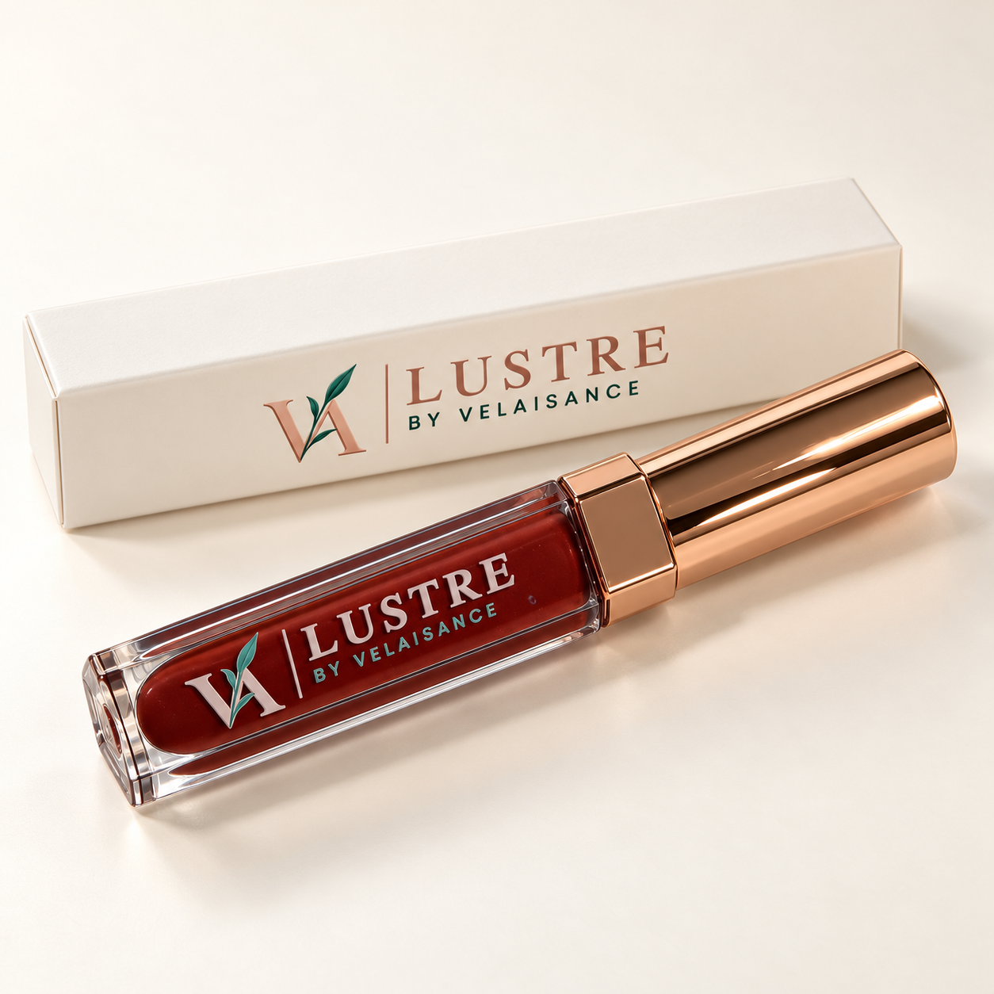
Website title Bordeaux | Berry Wine Lip Gloss
Brand and collection LUSTRE by Velaisance
Price $25.00 each
Shade and finish Berry Wine | Gloss finish
Size 5 mL / 0.17 fl oz. Box C22: 23 × 23 × 115.5 mm. Tube P245: 18 × 18 × 112 mm. Supplier-listed gross weight: 27.1 g; verify packed shipping weight separately.

Website description
Rich color. Unforgettable presence. Bordeaux is a deep berry-wine shade that adds a sultry finishing touch. Reach for it when your lips deserve to make the statement.
Suggested directions Apply with the included applicator to lips. Wear alone or over lip color and reapply as desired.
Suggested care For external use on lips only. Do not share applicators. Stop use if irritation occurs. Follow the supplier’s storage and period-after-opening guidance.
Ingredients Pending supplier’s full ingredient list; no ingredient or formulation claims assigned.
Suggested URL /elixir-vanity/bordeaux-lip-gloss
SEO title Bordeaux Lip Gloss | Velaisance
Meta description Shop Bordeaux lip gloss by Velaisance. Berry Wine for your lip wardrobe. Available at The Elixir Vanity.
Image alt text Bordeaux LUSTRE by Velaisance lip gloss with rose gold cap and ivory carton.

Cognac Lip Gloss
SKU EV-VEL-LGN-01
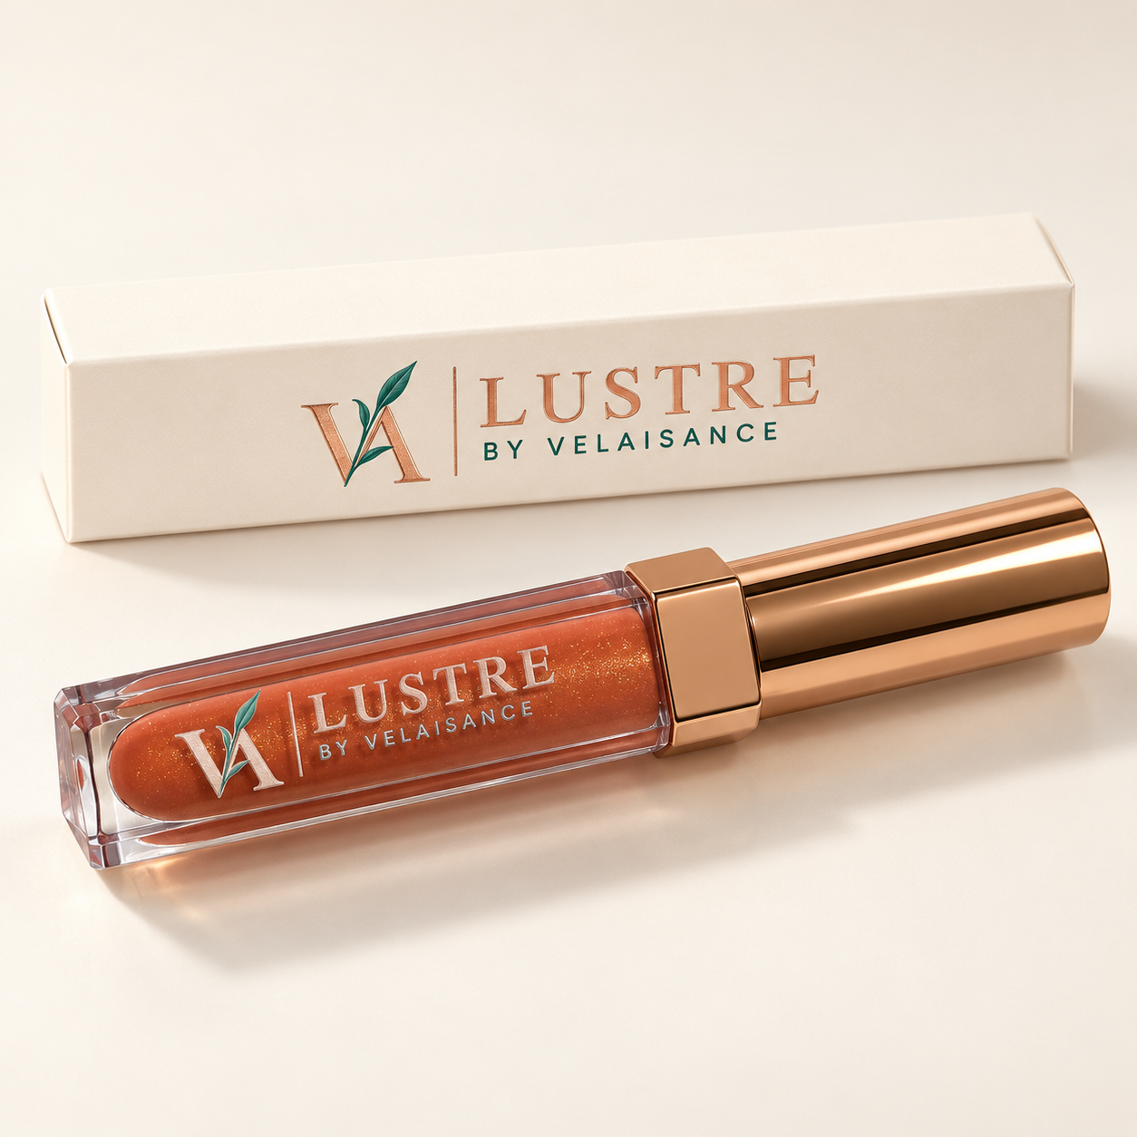
Website title Cognac | Copper Bronze Lip Gloss
Brand and collection LUSTRE by Velaisance
Price $25.00 each
Shade and finish Copper Bronze | Gloss finish
Size 5 mL / 0.17 fl oz. Box C22: 23 × 23 × 115.5 mm. Tube P245: 18 × 18 × 112 mm. Supplier-listed gross weight: 27.1 g; verify packed shipping weight separately.

Website description
Warm, rich, and undeniably inviting. Cognac blends copper and bronze tones for a radiant look with depth and dimension. A beautiful complement to warm neutrals and evening glamour.
Suggested directions Apply with the included applicator to lips. Wear alone or over lip color and reapply as desired.
Suggested care For external use on lips only. Do not share applicators. Stop use if irritation occurs. Follow the supplier’s storage and period-after-opening guidance.
Ingredients Pending supplier’s full ingredient list; no ingredient or formulation claims assigned.
Suggested URL /elixir-vanity/cognac-lip-gloss
SEO title Cognac Lip Gloss | Velaisance
Meta description Shop Cognac lip gloss by Velaisance. Copper Bronze for your lip wardrobe. Available at The Elixir Vanity.
Image alt text Cognac LUSTRE by Velaisance lip gloss with rose gold cap and ivory carton.

Rosé Lip Gloss
SKU EV-VEL-LGR-01
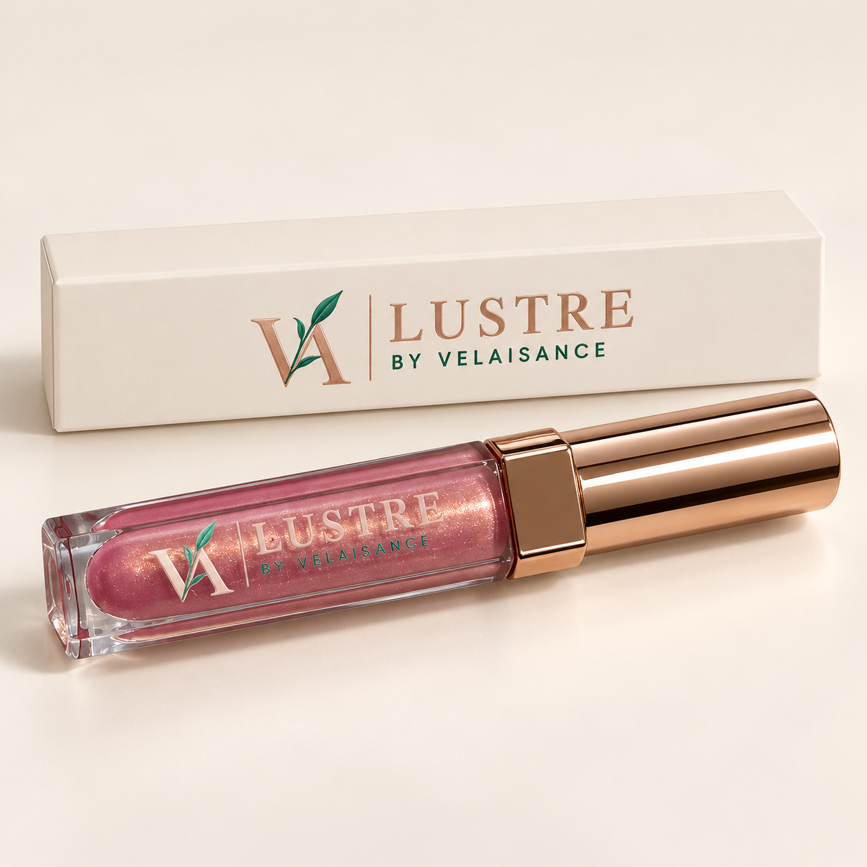
Website title Rosé | Blush Pink Lip Gloss
Brand and collection LUSTRE by Velaisance
Price $25.00 each
Shade and finish Blush Pink | Gloss finish
Size 5 mL / 0.17 fl oz. Box C22: 23 × 23 × 115.5 mm. Tube P245: 18 × 18 × 112 mm. Supplier-listed gross weight: 27.1 g; verify packed shipping weight separately.

Website description
Soft romance with a luminous touch. Rosé is a delicate blush pink that adds fresh, feminine polish to your look. Your invitation to make everyday moments feel a little more beautiful.
Suggested directions Apply with the included applicator to lips. Wear alone or over lip color and reapply as desired.
Suggested care For external use on lips only. Do not share applicators. Stop use if irritation occurs. Follow the supplier’s storage and period-after-opening guidance.
Ingredients Pending supplier’s full ingredient list; no ingredient or formulation claims assigned.
Suggested URL /elixir-vanity/rose-lip-gloss
SEO title Rosé Lip Gloss | Velaisance
Meta description Shop Rosé lip gloss by Velaisance. Blush Pink for your lip wardrobe. Available at The Elixir Vanity.
Image alt text Rosé LUSTRE by Velaisance lip gloss with rose gold cap and ivory carton.

Emerald Aire Candle
SKU EV-VEL-CEA-01
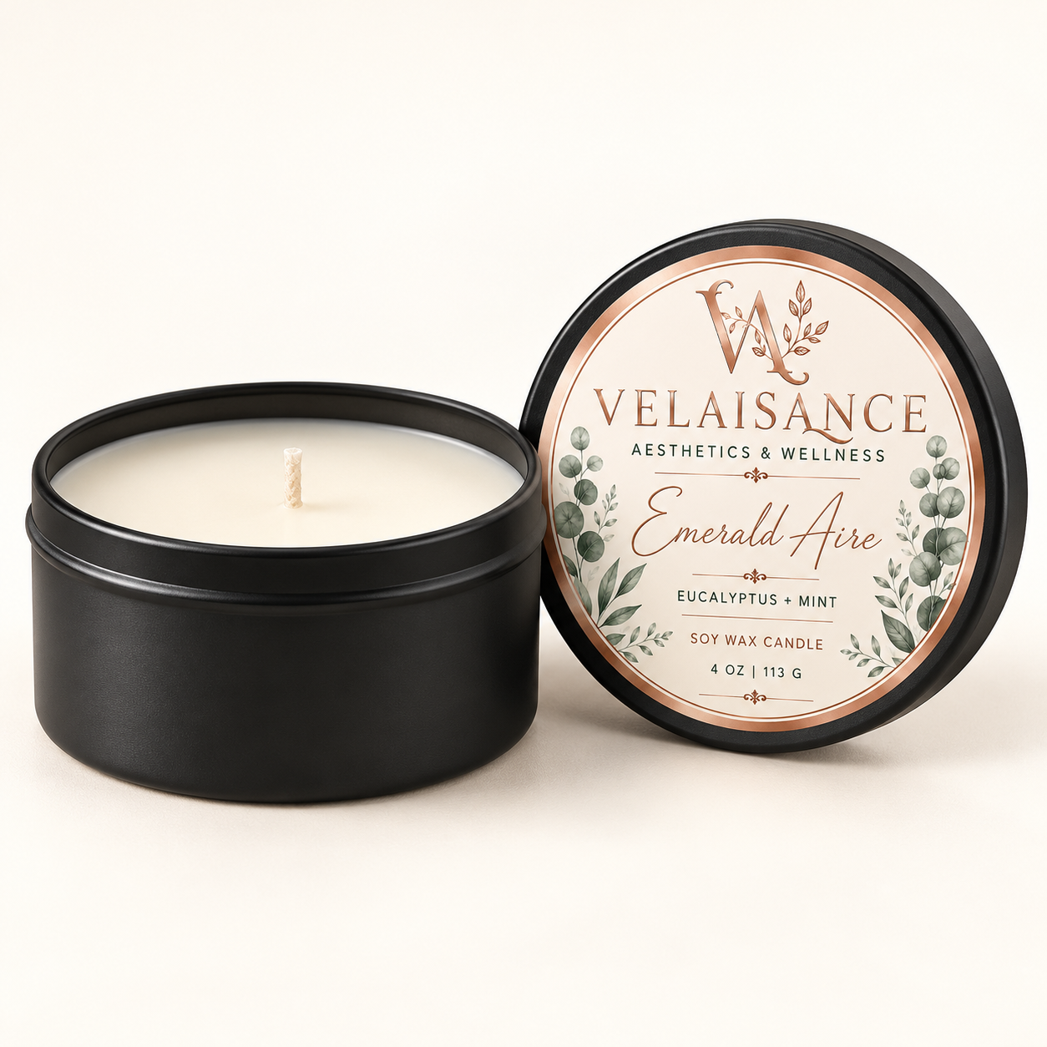
Website title Emerald Aire | Eucalyptus + Mint Candle
Brand and collection Velaisance | The Elixir Ritual Candle Collection
Price $19.99 each
Scent and specifications Eucalyptus + Mint | Soy wax | 4 oz / 113 g | Black tin | One candle

Website description
Bring the spa feeling home. Emerald Aire pairs crisp eucalyptus with cool mint for a fresh, botanical fragrance that makes your space feel renewed. A refreshing companion to morning rituals and moments of self-care.
Suggested care Burn within sight on a stable, heat-resistant surface. Keep away from drafts, flammable materials, children, and pets. Do not move a lit or hot candle. Extinguish before leaving the room.
Details to confirm Full wax and fragrance composition, wick material, burn time, trimming instructions, maximum burn session, and remaining-wax stop point. Soy wax is the supplied wax description.
Suggested URL /elixir-vanity/emerald-aire-candle
SEO title Emerald Aire Candle | Velaisance
Meta description Shop Emerald Aire candle by Velaisance. Eucalyptus + Mint for your home fragrance ritual. Available at The Elixir Vanity.
Image alt text Emerald Aire Eucalyptus + Mint soy candle in a black tin with lid.

Séréne Candle
SKU EV-VEL-CSE-01
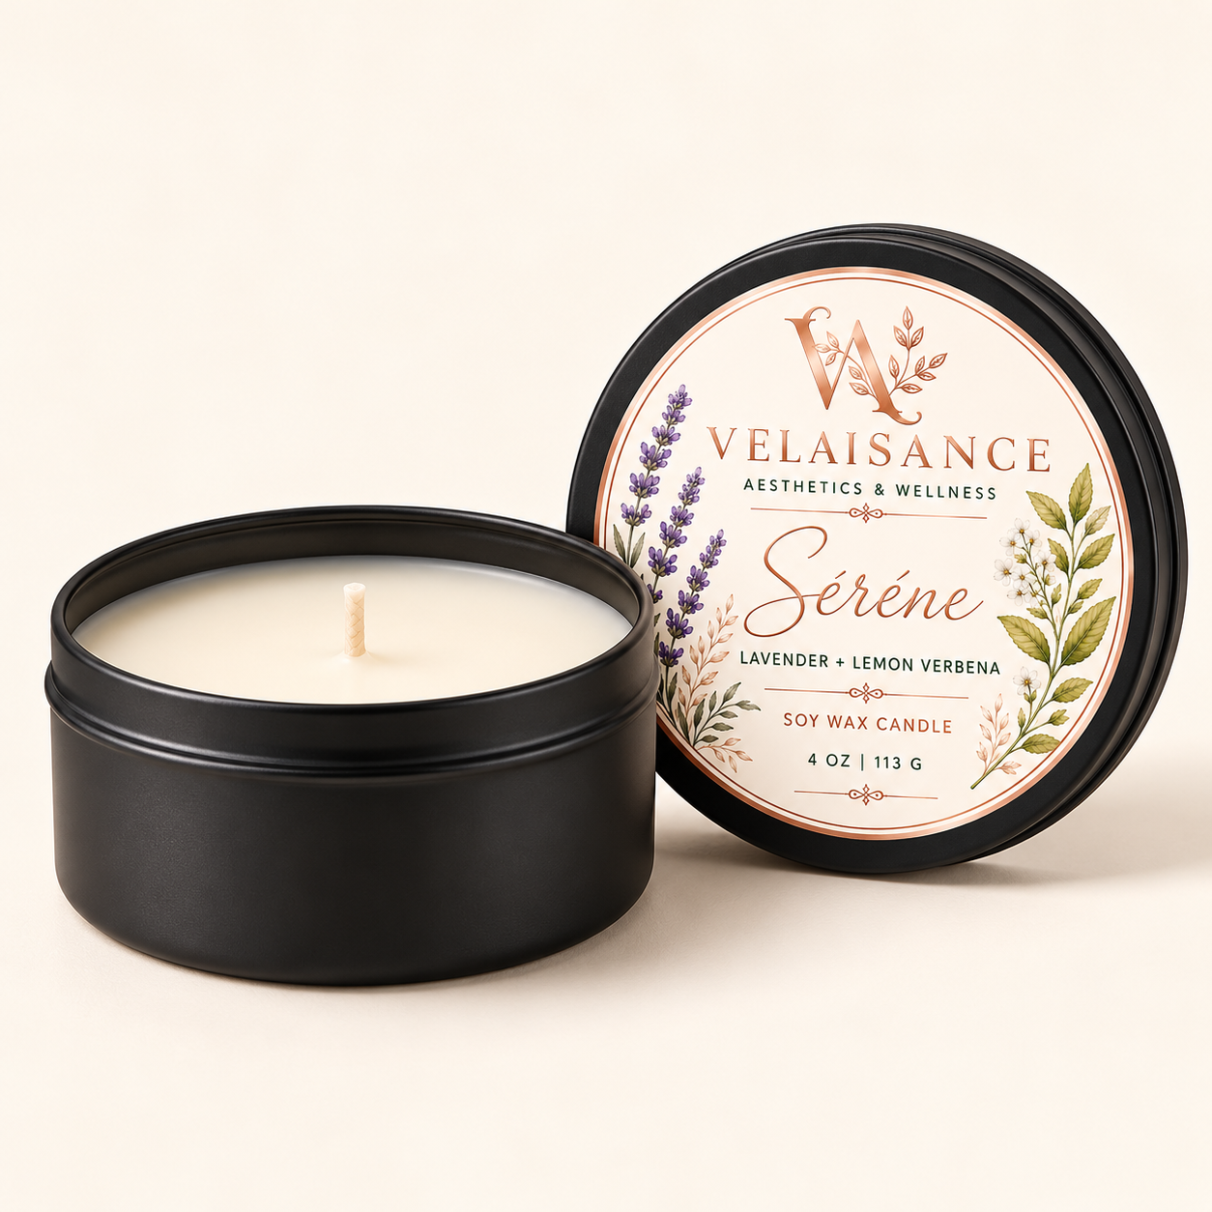
Website title Séréne | Lavender + Lemon Verbena Candle
Brand and collection Velaisance | The Elixir Ritual Candle Collection
Price $19.99 each
Scent and specifications Lavender + Lemon Verbena | Soy wax | 4 oz / 113 g | Black tin | One candle

Website description
Let the day soften around you. Séréne blends delicate lavender with the bright, citrusy scent of lemon verbena for a beautifully balanced floral fragrance. Set the scene for quiet evenings and unhurried moments.
Suggested care Burn within sight on a stable, heat-resistant surface. Keep away from drafts, flammable materials, children, and pets. Do not move a lit or hot candle. Extinguish before leaving the room.
Details to confirm Full wax and fragrance composition, wick material, burn time, trimming instructions, maximum burn session, and remaining-wax stop point. Soy wax is the supplied wax description.
Suggested URL /elixir-vanity/serene-candle
SEO title Séréne Candle | Velaisance
Meta description Shop Séréne candle by Velaisance. Lavender + Lemon Verbena for your home fragrance ritual. Available at The Elixir Vanity.
Image alt text Séréne Lavender + Lemon Verbena soy candle in a black tin with lid.

Velours Candle
SKU EV-VEL-CVE-01
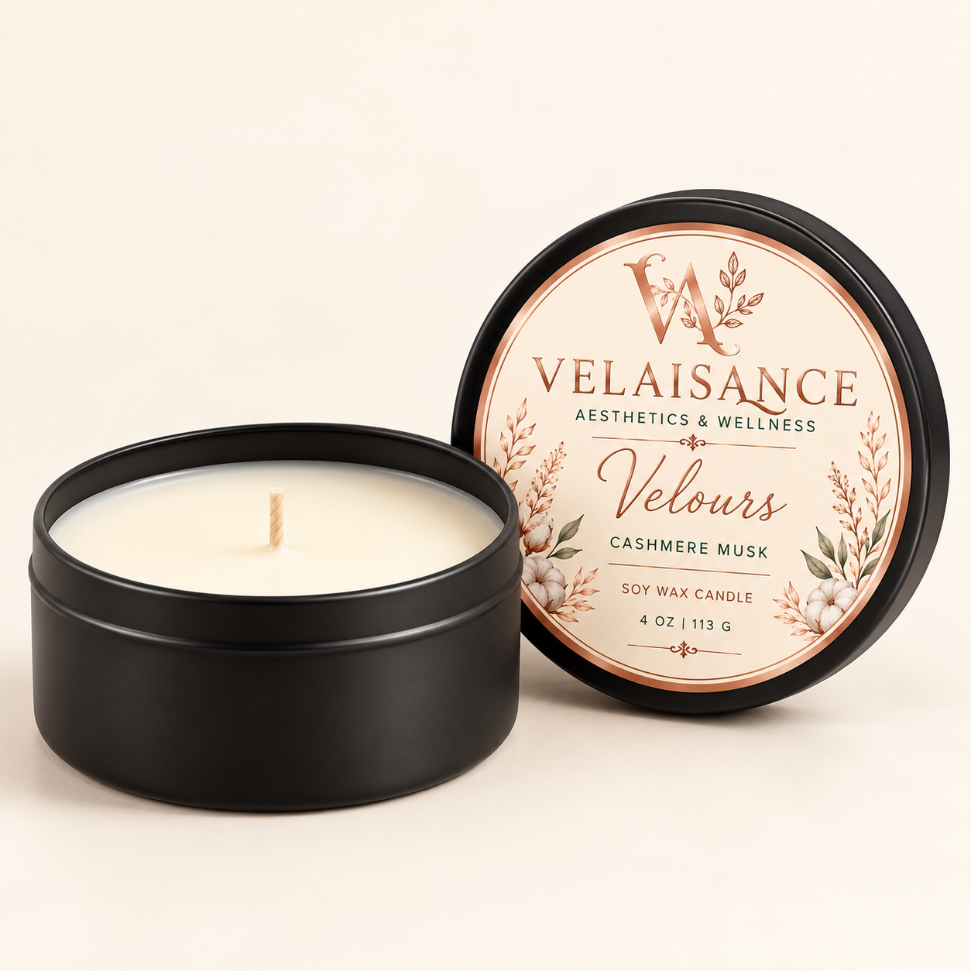
Website title Velours | Cashmere Musk Candle
Brand and collection Velaisance | The Elixir Ritual Candle Collection
Price $19.99 each
Scent and specifications Cashmere Musk | Soy wax | 4 oz / 113 g | Black tin | One candle

Website description
Wrap your space in quiet luxury. Velours features soft cashmere musk for a warm, enveloping fragrance that feels intimate and inviting. An elegant finishing touch for cozy evenings and your favorite corners of home.
Suggested care Burn within sight on a stable, heat-resistant surface. Keep away from drafts, flammable materials, children, and pets. Do not move a lit or hot candle. Extinguish before leaving the room.
Details to confirm Full wax and fragrance composition, wick material, burn time, trimming instructions, maximum burn session, and remaining-wax stop point. Soy wax is the supplied wax description.
Suggested URL /elixir-vanity/velours-candle
SEO title Velours Candle | Velaisance
Meta description Shop Velours candle by Velaisance. Cashmere Musk for your home fragrance ritual. Available at The Elixir Vanity.
Image alt text Velours Cashmere Musk soy candle in a black tin with lid.

Sanctuaire Candle
SKU EV-VEL-CSA-01
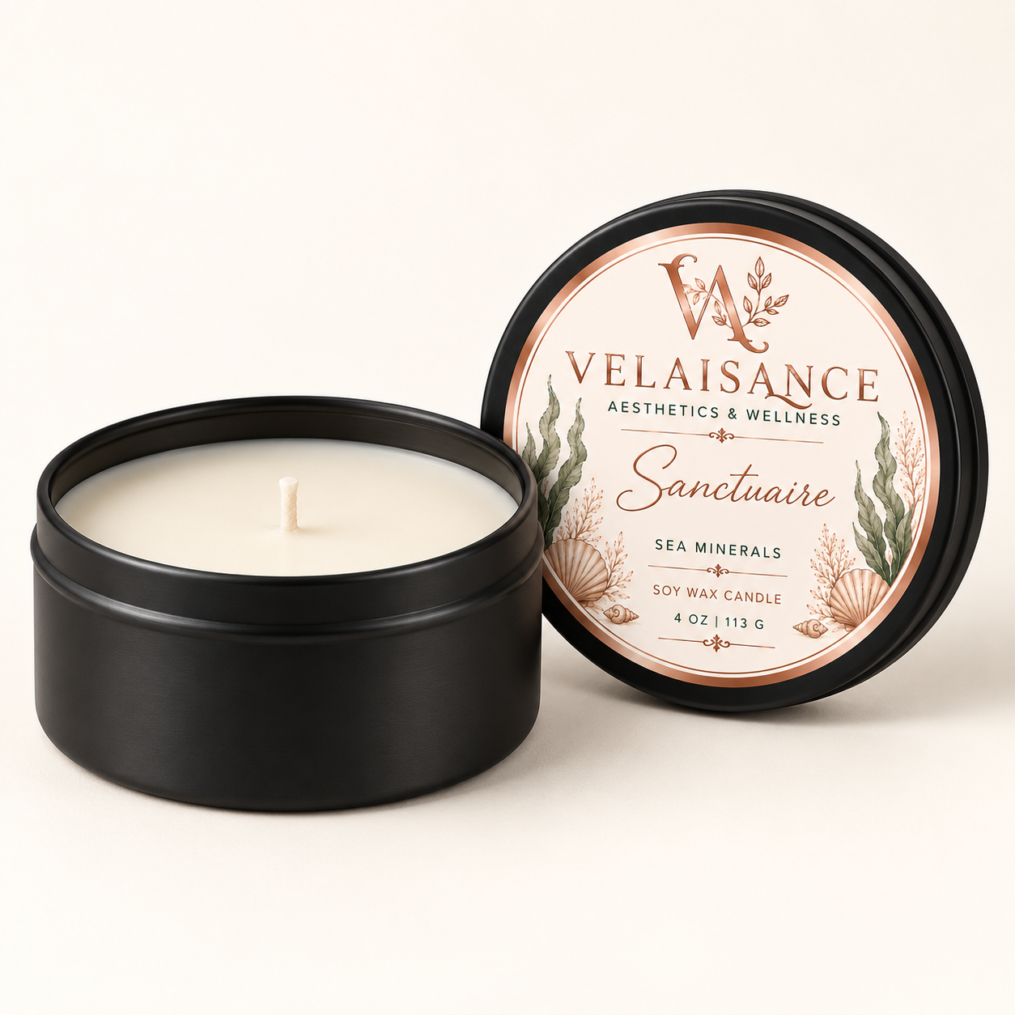
Website title Sanctuaire | Sea Minerals Candle
Brand and collection Velaisance | The Elixir Ritual Candle Collection
Price $19.99 each
Scent and specifications Sea Minerals | Soy wax | 4 oz / 113 g | Black tin | One candle

Website description
Your everyday escape. Sanctuaire captures the fresh, airy character of sea minerals in an ocean-inspired fragrance that brings coastal elegance to your surroundings. Create a welcoming retreat, wherever you call home.
Suggested care Burn within sight on a stable, heat-resistant surface. Keep away from drafts, flammable materials, children, and pets. Do not move a lit or hot candle. Extinguish before leaving the room.
Details to confirm Full wax and fragrance composition, wick material, burn time, trimming instructions, maximum burn session, and remaining-wax stop point. Soy wax is the supplied wax description.
Suggested URL /elixir-vanity/sanctuaire-candle
SEO title Sanctuaire Candle | Velaisance
Meta description Shop Sanctuaire candle by Velaisance. Sea Minerals for your home fragrance ritual. Available at The Elixir Vanity.
Image alt text Sanctuaire Sea Minerals soy candle in a black tin with lid.

Séréne Room and Linen Spray
SKU EV-VEL-SSL-01
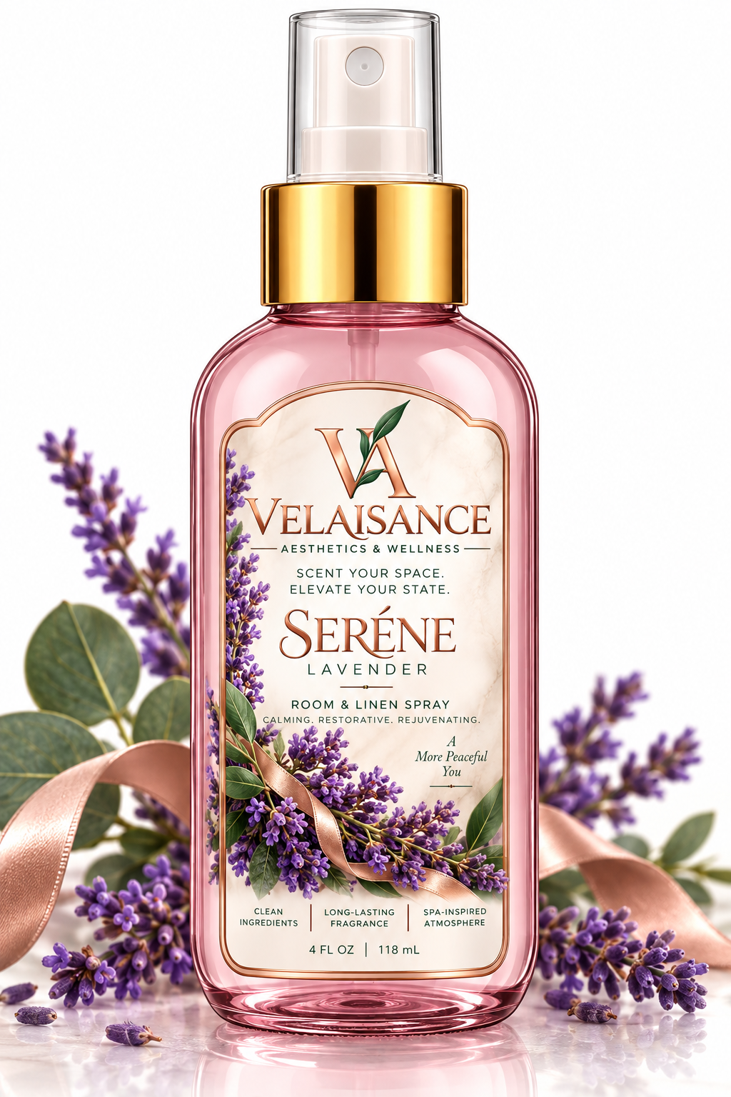
Website title Séréne | Lavender Room and Linen Spray
Brand and collection Velaisance | The Elixir Atmosphere Collection
Price $20.00 each | Any two room and linen sprays for $35.00
Scent and specifications Lavender | Room and linen spray | 4 fl oz / 118 mL | One spray bottle

Website description
A softer atmosphere starts here. Séréne brings the familiar floral fragrance of lavender to your space, adding a gentle finishing touch to your evening rituals. Turn an everyday room into somewhere you love to linger.
Suggested directions Mist into the air. Use on linens only where supplier directions permit; patch-test an inconspicuous area first and allow to dry.
Suggested care Room and linen use only; do not apply to skin or ingest. Avoid eyes, pets, food, and delicate fabrics. Keep out of reach of children. Confirm formula-specific flammability, storage, and surface warnings with the supplier.
Ingredients Not supplied. Lavender and eucalyptus identify scents and do not establish essential oil content or the complete formula.
Suggested URL /elixir-vanity/serene-room-linen-spray
SEO title Séréne Room and Linen Spray | Velaisance
Meta description Shop Séréne room and linen spray by Velaisance. Lavender for your home fragrance ritual. Available at The Elixir Vanity.
Image alt text Séréne Lavender room and linen spray bottle by Velaisance.

Clear Mind Room and Linen Spray
SKU EV-VEL-SCE-01
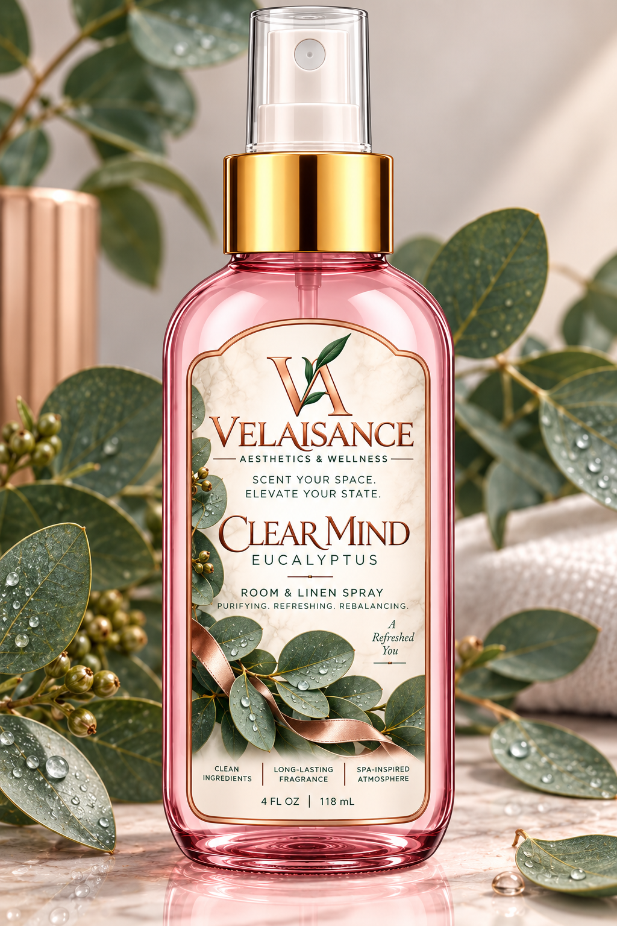
Website title Clear Mind | Eucalyptus Room and Linen Spray
Brand and collection Velaisance | The Elixir Atmosphere Collection
Price $20.00 each | Any two room and linen sprays for $35.00
Scent and specifications Eucalyptus | Room and linen spray | 4 fl oz / 118 mL | One spray bottle

Website description
Refresh your surroundings with eucalyptus’s crisp, botanical fragrance. Clear Mind brings a clean-smelling, spa-inspired atmosphere to your space—a simple touch of everyday luxury.
Suggested directions Mist into the air. Use on linens only where supplier directions permit; patch-test an inconspicuous area first and allow to dry.
Suggested care Room and linen use only; do not apply to skin or ingest. Avoid eyes, pets, food, and delicate fabrics. Keep out of reach of children. Confirm formula-specific flammability, storage, and surface warnings with the supplier.
Ingredients Not supplied. Lavender and eucalyptus identify scents and do not establish essential oil content or the complete formula.
Suggested URL /elixir-vanity/clear-mind-room-linen-spray
SEO title Clear Mind Room and Linen Spray | Velaisance
Meta description Shop Clear Mind room and linen spray by Velaisance. Eucalyptus for your home fragrance ritual. Available at The Elixir Vanity.
Image alt text Clear Mind Eucalyptus room and linen spray bottle by Velaisance.

